**GIT Remoting**

**Objective:** Pushing source code into GITHUB & collaborate team members.

SECTION-1

39. Create a GitHub account if you do not have already.

GitHub Account link: https://github.com/palashpadiya4

40. Login on into github account.

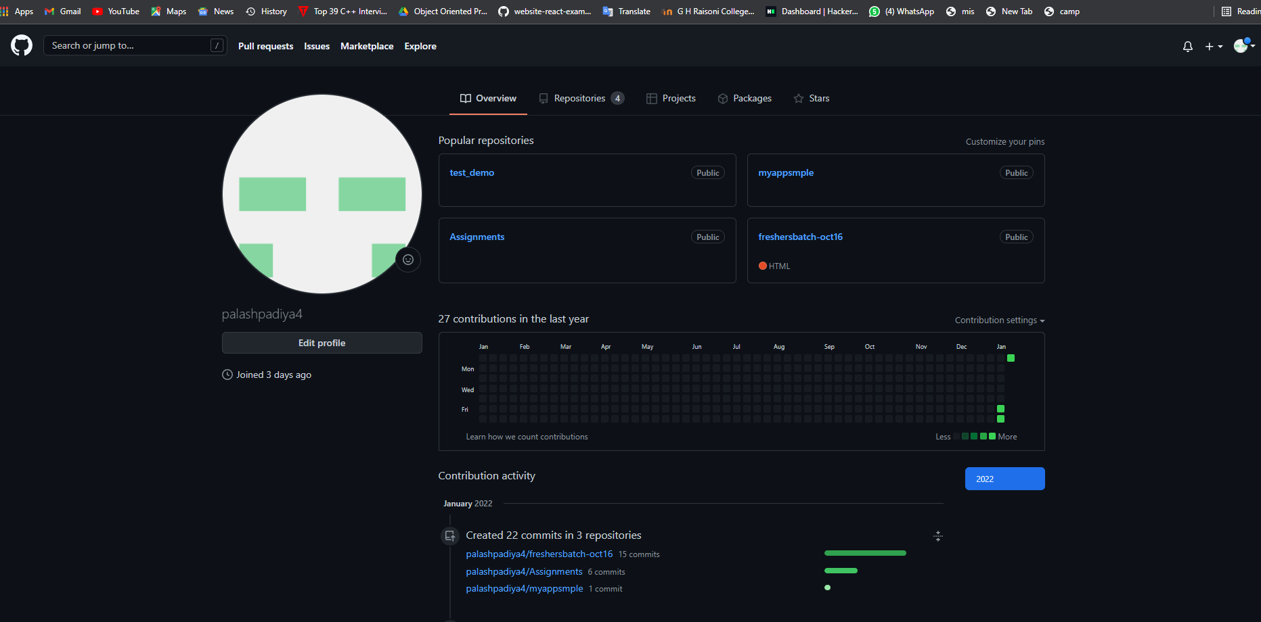

41. Create new public repository ‘freshersbatch-oct16’.

Click on New Repository

8

In Repository name field type the name of the repository as in this I have typed ‘freshersbatch-oct16’ then check the public after that click on create repository to create a new repository.

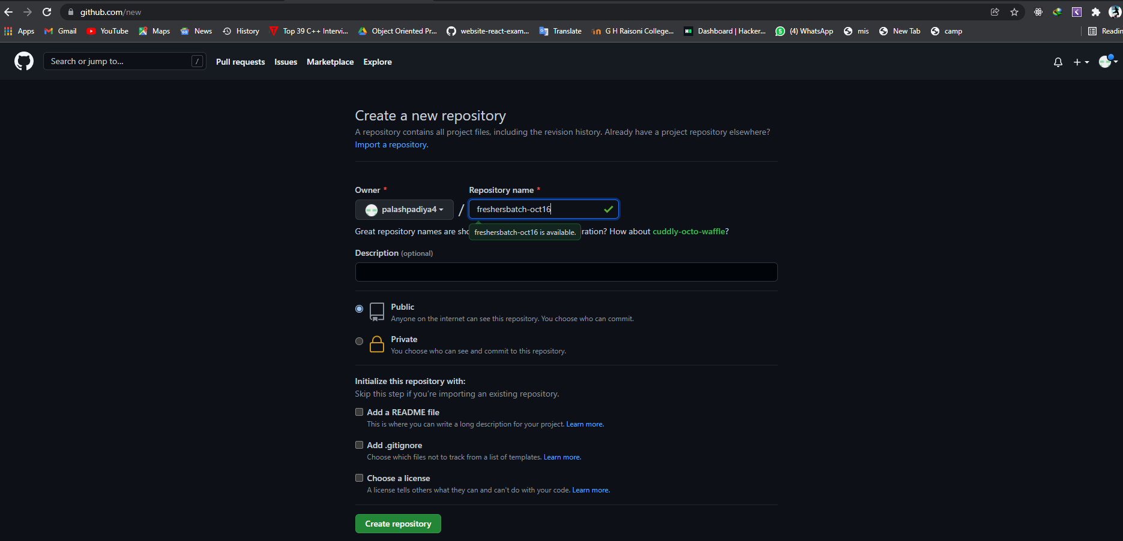

42. Commit & push any sample file to this repository under ‘Assignments’ directory.

Output:

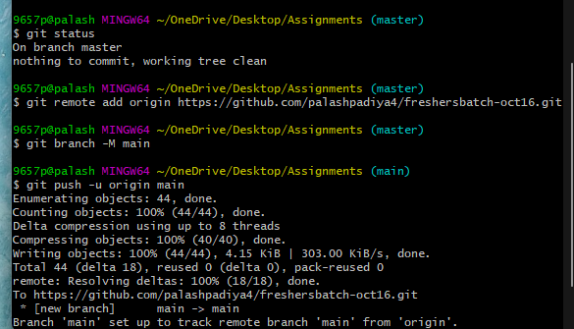

Changes in GitHub Repository:

